* Title of the Game : Simple ping pong ball game .
* The Description of this game:

a ball moves continuously in the directions of the four axes

And it is controlled by a rectangle that moves left when you press ‘B’ and right when you press ‘N’ , when the ball catches the parameter of the moving rectangle your score increases by 1 , when the ball doesn’t touch it the game is over and score is printed

* Shapes + opject :
* Ball :

// drawing of circle centre at (0, 0) iterated up to 2*pi, i.e., 360 degree

while (i <= 2 * pi)

{

y = 20 * cos(i);

x = 20 * sin(i);

i = i + .1;

// flag1 is 0 to show motion in upward direction and is 1 for downward direction

if (m == 288 && flag1 == 0)//flag 0 upword

{

j = -1;

m = -288;

flag1 = 1;

score++;

}

if (m == 288 && flag1 == 1)//flag 1 downword

{

j = 1;

m = -288;

flag1 = 0;

}

// flag2 is 0 to show motion in rightward direction and is 1 for leftward direction

if (n == 580 && flag2 == 0)//flag =0 to right

{

l = -1;

n = -580;

flag2 = 1;

}

if (n == 580 && flag2 == 1)//flag = 1 to left

{

l = 1;

n = -580;

flag2 = 0;

}

// equation for desired motion of ball

glVertex2i((x - l * n), (y - j * m));

}

* Rectangle for catching the ball:

// these four points draws smaller rectangle which is for catching ball

glBegin(GL_LINE_LOOP);

left = -200 + 200 * (d - c);

right = 200 + 200 * (d - c);

glVertex2i(left, -315);

glVertex2i(left, -295);

glVertex2i(right, -295);

glVertex2i(right, -315);

glEnd();

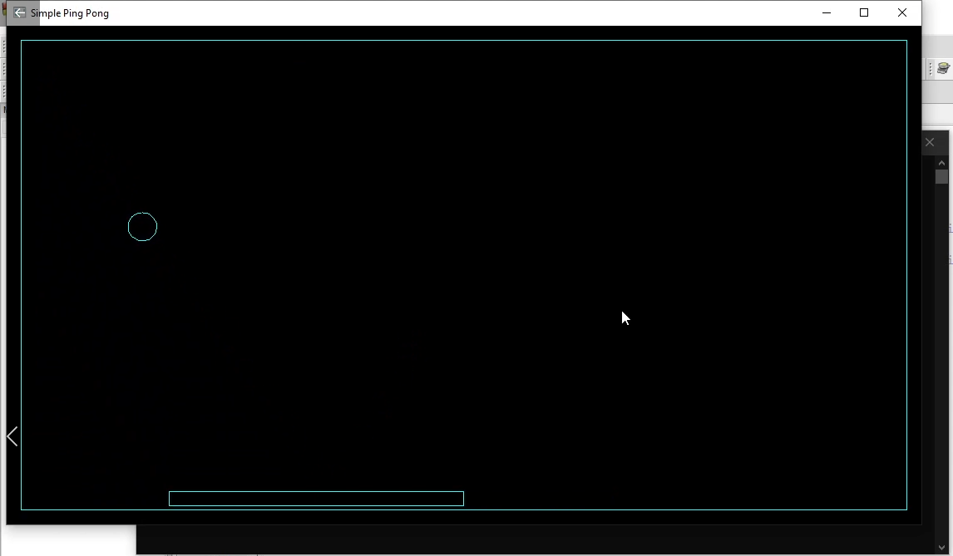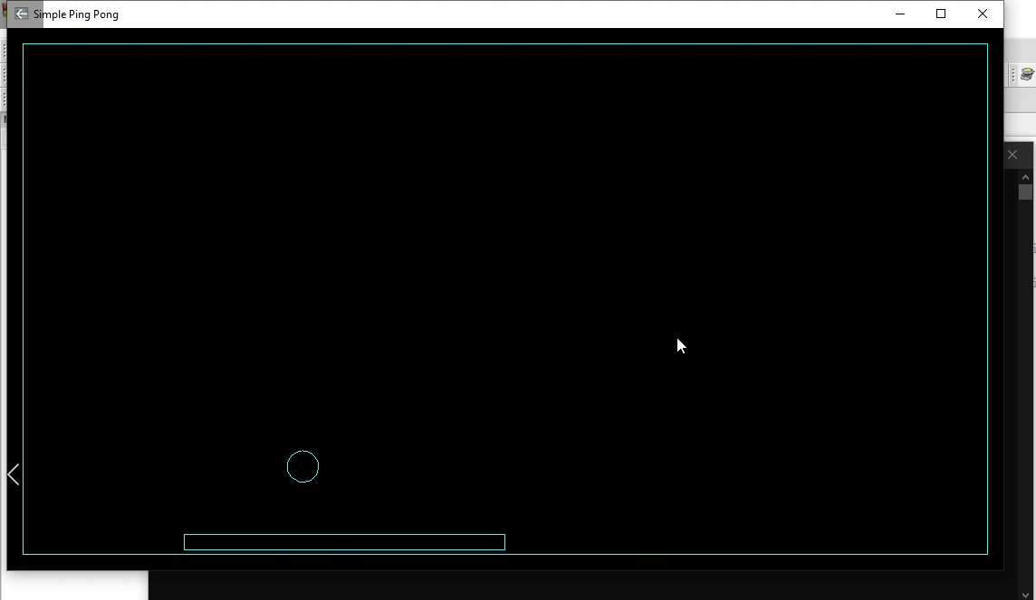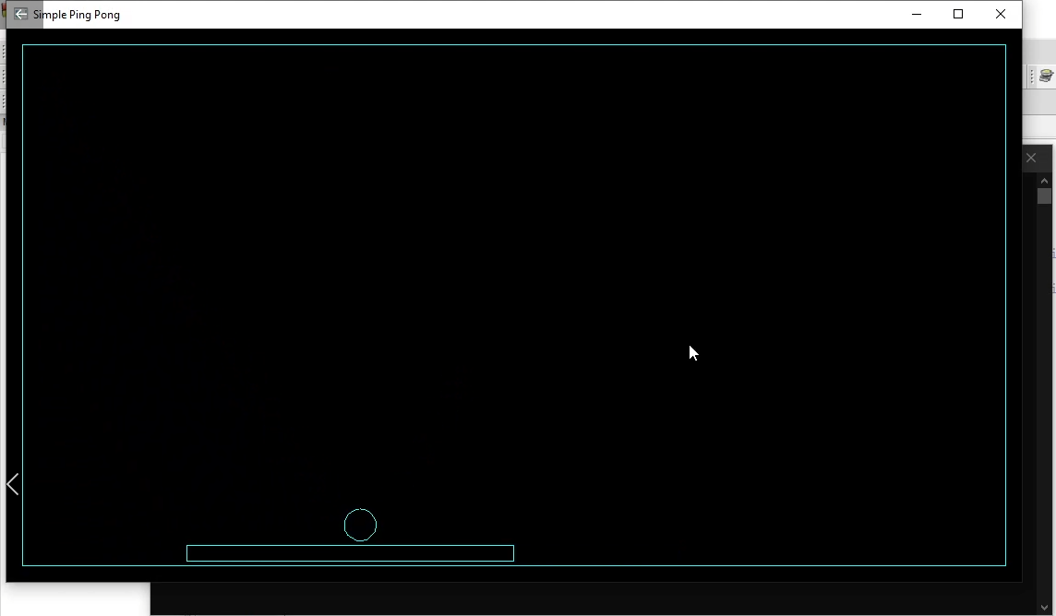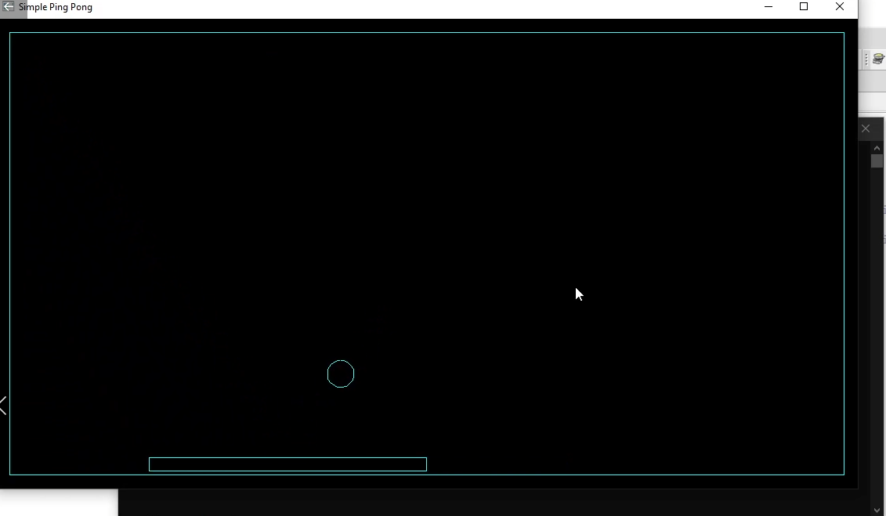

When the ball doesn’t touch the parameter of the rectangle

